
Section 1: Hosted API LLM Architecture

Diagram A — Hosted API LLM Architecture
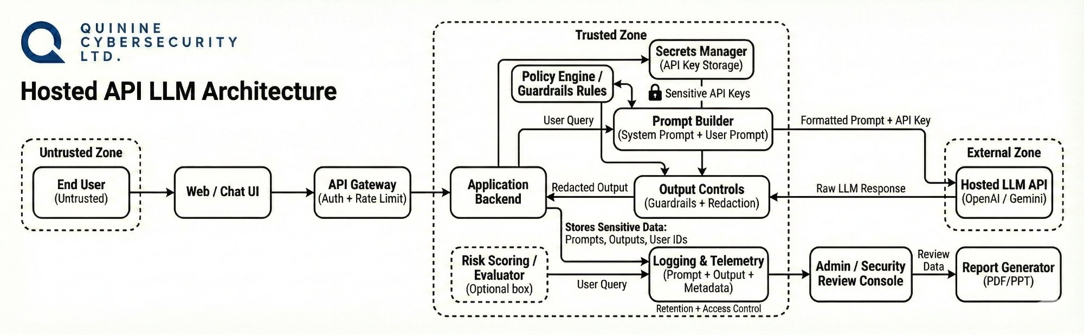

1.1 Data Flow Summary
The following summarizes the end-to-end request lifecycle through the Hosted API LLM Architecture:

- End User submits a prompt via a Web / Chat UI or direct API call from a client application.
- Request arrives at the API Gateway where SSL termination, rate limiting, and initial routing checks are applied.
- Auth & Identity Layer validates the API key or session token; rejected requests are blocked before touching the model.
- System Prompt is retrieved from the Prompt Store and prepended to the user input to form the full context payload.
- Combined payload (system prompt + user prompt) is transmitted over a secured channel to the Hosted LLM API (OpenAI / Gemini) in the External Zone.
- The hosted model generates a raw response; optional tool / function calls may occur during this step.
- Raw response re-enters the Trusted Zone and passes through Output Controls (Guardrails + Redaction) before being returned to the user.
- Complete interaction — prompt, raw response, redacted output, and metadata — is written to the Logging & Telemetry system for audit, with retention and access controls applied.

1.2 Trust Boundaries Summary
Three distinct trust zones govern data movement in this architecture. All external interactions cross a clearly defined boundary with enforced controls at each transition point.

Trust Zone | Level | Components Included
TRUSTED | Internal / Fully Controlled | Application Backend, Prompt Builder, Output Controls (Guardrails + Redaction), Secrets Manager, Policy Engine, Logging & Telemetry, Admin / Security Review Console
SEMI-TRUSTED | Third-Party / Vendor-Managed | Hosted LLM API (OpenAI / Gemini), External Tool APIs, OAuth Providers — governed by vendor SLAs but outside direct control
UNTRUSTED | External / Potentially Adversarial | End User Input via Web / Chat UI, File Uploads, URLs referenced in prompts, Web-retrieved content injected into prompts

1.3 Top Risks
The following risks represent the most significant security concerns for the Hosted API LLM deployment, mapped to OWASP LLM Top 10 (2025) and MITRE ATLAS:

Risk ID | OWASP / Framework | Risk Statement
R-LLM-01 | LLM01 — Prompt Injection MITRE: AML.T0051 | If a user embeds malicious instructions in their input, then the model may override its system prompt and follow attacker-controlled commands, bypassing intended behaviour.
R-LLM-02 | LLM01 — Indirect Injection MITRE: AML.T0054 | If the model processes external content (web results, uploaded files) without sanitisation, then injected instructions within that content may hijack model behaviour mid-session.
R-LLM-03 | LLM02 — Info Disclosure | If user PII is included in prompts without sanitisation controls, then sensitive data may be echoed back in model output or persisted insecurely in logs.
R-LLM-04 | LLM07 — System Prompt Leakage MITRE: AML.T0056 | If the system prompt is not protected against extraction, then confidential business logic or security control instructions may be revealed through iterative probing.
R-LLM-05 | LLM06 — Excessive Agency MITRE: AML.T0048 | If the model has access to external tools and receives a crafted prompt, then it may trigger unintended real-world API calls, writes, or automated actions without human approval.
R-LLM-06 | LLM10 — Unbounded Consumption | If rate limiting is absent or misconfigured on the API Gateway, then an attacker may conduct mass prompt testing, model extraction attacks, or cause service degradation / denial.
R-LLM-07 | LLM03 — Supply Chain MITRE: AML.T0010 | If a third-party model, library, or plugin is compromised before deployment, then attackers may have a persistent backdoor into the application that is invisible to runtime monitoring.
R-LLM-08 | LLM05 — Improper Output Handling | If model outputs are passed to downstream systems (code interpreters, browsers, databases) without validation, then malicious content may be executed as trusted system instructions.

1.4 Testing Focus Areas
Testing priorities are ordered by severity and mapped directly to OWASP LLM Top 10 categories and corresponding MITRE ATLAS techniques:

Priority | OWASP / MITRE | Test Category | Description
🔴 Critical | LLM01 MITRE: AML.T0051 | Prompt Injection | Attempt to override system instructions via crafted direct and indirect user input across multiple injection vectors.
🔴 Critical | LLM01 MITRE: AML.T0054 | Jailbreaking | Use roleplay, hypothetical framing, and encoding tricks to bypass safety filters and extract restricted model behaviour.
🔴 Critical | LLM01 MITRE: AML.T0054 | Indirect Prompt Injection | Inject instructions via external content sources: web results, document uploads, and URL-sourced data processed by the model.
🟠 High | LLM07 MITRE: AML.T0056 | System Prompt Extraction | Probe iteratively to reveal hidden system prompt content through carefully crafted user queries and reflection techniques.
🟠 High | LLM02 | Data & PII Leakage | Test for inadvertent disclosure of sensitive data, cross-session memory bleed, and PII echoing in model responses.
🟠 High | LLM06 MITRE: AML.T0048 | Excessive Agency / Tool Misuse | Trigger unintended external tool or API calls via crafted prompts; verify the model cannot cause write actions without authorisation.
🟠 High | LLM03 MITRE: AML.T0010 | Supply Chain Integrity | Validate provenance of all models, libraries, plugins, and dependencies used in the hosted pipeline.
🟡 Medium | LLM10 | Rate Limit & DoS | Probe for missing or weak rate limiting; test for model extraction and unbounded consumption attack viability.
🟡 Medium | LLM05 | Improper Output Handling | Verify downstream systems do not blindly execute or trust raw model output; test for code injection via LLM responses.
🟢 Standard | — | Auth & Access Control | Test authentication, authorisation, API key management, and session isolation between users.

Section 2: Local / Self-Hosted LLM Architecture

Diagram B — Local / Self-Hosted LLM Architecture
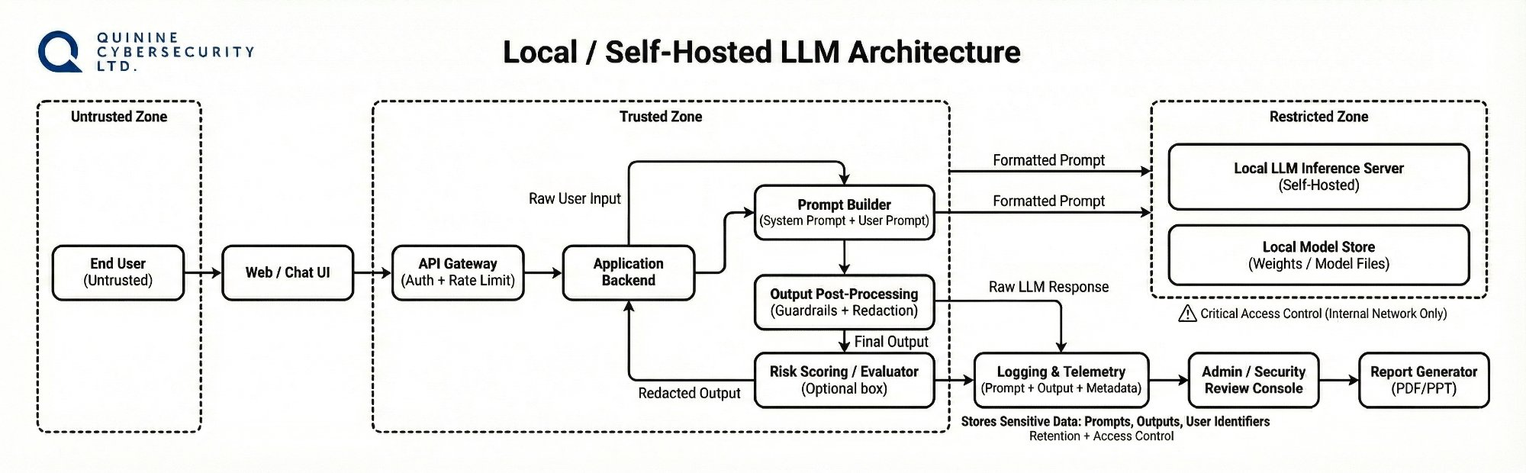

2.1 Data Flow Summary
The following summarises the end-to-end request lifecycle through the Local / Self-Hosted LLM Architecture (e.g. Ollama):

- End User (Untrusted) submits a natural language prompt via the Web / Chat UI.
- Request enters the Trusted Zone through the API Gateway, where authentication and rate limiting are enforced before any further processing.
- Application Backend receives the validated request and coordinates the Prompt Builder and Post-Processing components.
- Prompt Builder assembles the formatted prompt from the system prompt and the user query; two parallel paths dispatch the formatted prompt to the Local LLM Inference Server.
- Local LLM Inference Server (self-hosted, e.g. Ollama) processes the prompt using model weights stored in the Local Model Store — both components reside in the Restricted Zone (internal network only).
- Raw LLM Response is returned from the Restricted Zone to the Output Post-Processing component, which applies guardrails and redaction before producing the final output.
- Risk Scoring / Evaluator (optional) analyses the redacted output and feeds a quality signal back to the Application Backend.
- Final output is delivered to the user; all prompts, outputs, and metadata are recorded in Logging & Telemetry for retention and access-controlled audit review.

2.2 Trust Boundaries Summary
This architecture introduces a dedicated Restricted Zone for the self-hosted inference server and model weights, separated from both the Trusted Zone and the external network.

Trust Zone | Level | Components Included
TRUSTED | Internal / Fully Controlled | Application Backend, Prompt Builder, Output Post-Processing (Guardrails + Redaction), Risk Scoring / Evaluator, Logging & Telemetry, Admin / Security Review Console, Report Generator
RESTRICTED | Internal Network Only — Critical Access Control | Local LLM Inference Server (self-hosted), Local Model Store (weights / model files) — network-isolated; no external egress permitted
UNTRUSTED | External / Potentially Adversarial | End User input via Web / Chat UI — treated as untrusted; raw input must never reach the model without validation

2.3 Top Risks
The self-hosted deployment introduces unique risks around model integrity, network exposure, and reduced vendor-enforced safety controls, in addition to standard LLM risks:

Risk ID | OWASP / Framework | Risk Statement
R-LOC-01 | LLM04 — Model Poisoning MITRE: AML.T0020 | If the local model weights are sourced from an unverified repository or modified after download, then attacker-planted backdoor behaviours may surface under specific trigger prompts at runtime.
R-LOC-02 | LLM01 — Prompt Injection MITRE: AML.T0051 | If a user embeds adversarial instructions in a prompt, then the self-hosted model — which may lack vendor-level safety tuning — may comply more readily than a hardened hosted API.
R-LOC-03 | LLM03 — Supply Chain MITRE: AML.T0010 | If the inference framework (Ollama), model files, or runtime libraries are not verified for integrity, then a compromised component may introduce a persistent backdoor into the local deployment.
R-LOC-04 | Restricted Zone Exposure MITRE: AML.T0042 | If the Local LLM Inference Server or Model Store is accessible beyond the internal network boundary, then an attacker with network access may query the model directly, bypassing all application-layer controls.
R-LOC-05 | LLM05 — Improper Output Handling | If the Output Post-Processing guardrails are insufficiently configured for the specific local model, then harmful or policy-violating outputs may reach the user unfiltered.
R-LOC-06 | LLM02 — Sensitive Data in Logs MITRE: AML.T0036 | If Logging & Telemetry captures full prompt and output content without redaction, then sensitive data (PII, credentials, business information) may be exposed to anyone with log access.
R-LOC-07 | LLM10 — Unbounded Consumption | If the local inference server has no resource quotas, then a user or script may submit high-volume or computationally expensive prompts, causing resource exhaustion and denial of service.
R-LOC-08 | LLM07 — System Prompt Leakage MITRE: AML.T0056 | If the system prompt is stored in a retrievable configuration file or environment variable, then an attacker with host access may exfiltrate the full system prompt without interacting with the model.

2.4 Testing Focus Areas
Testing priorities for the local deployment emphasise model integrity, Restricted Zone exposure, and supply chain controls, in addition to standard prompt injection testing:

Priority | OWASP / MITRE | Test Category | Description
🔴 Critical | LLM01 MITRE: AML.T0051 | Prompt Injection (Local Model) | Attempt direct and indirect injection against the self-hosted model; test whether reduced safety fine-tuning increases susceptibility vs hosted APIs.
🔴 Critical | LLM04 MITRE: AML.T0020 | Model Integrity Verification | Verify cryptographic checksums of all downloaded model weights; test for backdoor trigger phrases introduced via data poisoning.
🔴 Critical | Restricted Zone MITRE: AML.T0042 | Inference Server Exposure | Confirm the Local LLM Inference Server is not accessible outside the internal network; test for direct API access bypassing application controls.
🟠 High | LLM03 MITRE: AML.T0010 | Supply Chain Integrity | Validate integrity of inference framework, runtime libraries, and all model dependencies before and after deployment.
🟠 High | LLM07 MITRE: AML.T0056 | System Prompt Extraction | Probe to reveal the local system prompt; also check configuration files and environment variables for plaintext exposure.
🟠 High | LLM05 | Output Guardrail Bypass | Test completeness of local guardrails; attempt bypass techniques that may succeed against models without vendor-level safety tuning.
🟡 Medium | LLM02 MITRE: AML.T0036 | Log Data Exposure | Review logging configuration for sensitive prompt / output content; test redaction effectiveness before log storage.
🟡 Medium | LLM10 | Resource Exhaustion / DoS | Submit computationally expensive prompts to test rate limiting and resource quotas on the local inference server.
🟢 Standard | — | Auth & Network Segmentation | Validate that all Restricted Zone components are network-isolated; test access control enforcement on inference endpoints.

Section 3: RAG Based Internal Chatbot Architecture

Diagram C — RAG Based Internal Chatbot Architecture
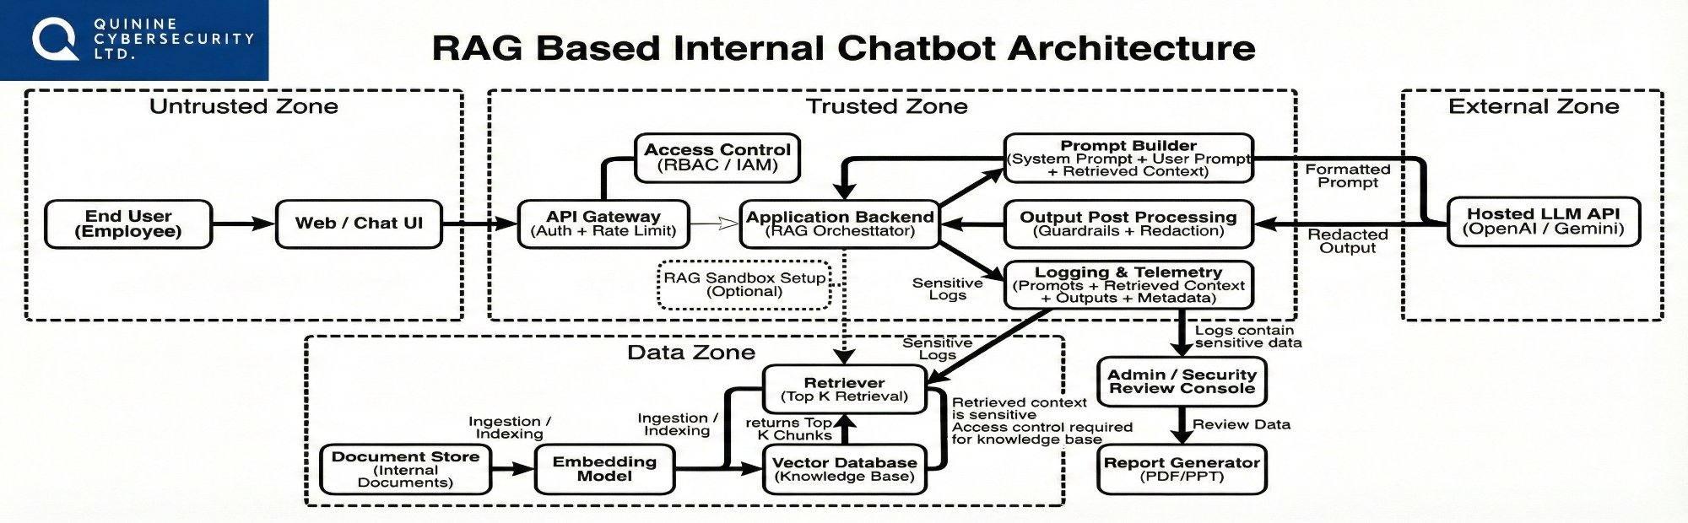

3.1 What is RAG?
Retrieval-Augmented Generation (RAG) is an AI architecture in which the model retrieves relevant document chunks from an external vector database before generating a response. Unlike a plain LLM deployment, the knowledge base (document store, embedding model, and vector database) now forms part of the attack surface. A poisoned document can inject instructions that the LLM will follow as if they were trusted system commands. This introduces six or more additional attack vectors beyond a standard LLM deployment.

3.2 Data Zone Mapping
The RAG pipeline spans three security zones. The table below maps each critical pipeline component to its zone, its role, and the primary security controls required:

Component | Zone | Role in Pipeline | Security Notes
Document Store | Data Zone | Stores raw internal documents (PDFs, wikis, databases) pending ingestion into the RAG pipeline | Access must be strictly controlled; untrusted uploads are a primary poisoning vector — validate and scan all ingested files
Embedding Model | Data Zone | Converts document text and user queries into high-dimensional vector representations for semantic search | Model provenance must be verified; a tampered embedding model silently compromises all downstream retrieval results
Vector Database | Data Zone (Knowledge Base) | Stores embedded document chunks; queried at inference time to retrieve the most semantically relevant chunks for the user query | Requires authentication, authorisation, and tenant isolation; unauthenticated access allows direct embedding poisoning or data exfiltration
Retriever (Top-K) | Trusted Zone | Executes the similarity search against the Vector DB and returns the top-K most relevant chunks to the Application Backend | Retrieved context is sensitive — access control must be enforced per-user; excessive chunk return enables context overflow / DoS

3.3 RAG-Specific Risks
The following risks are specific to or significantly amplified by the RAG architecture. Each is mapped to OWASP LLM Top 10 (2025) and MITRE ATLAS where applicable:

Risk ID | OWASP / Framework | Risk Statement
R-RAG-01 | LLM01 — Document Poisoning MITRE: AML.T0020 | If a malicious document is uploaded to the knowledge base, then it may contain hidden instructions that manipulate LLM responses when those chunks are retrieved and passed as context.
R-RAG-02 | LLM01 — Indirect Injection MITRE: AML.T0054 | If retrieved document chunks contain injected instructions, then the LLM may treat document content as system commands rather than passive context, hijacking response behaviour.
R-RAG-03 | LLM02 — Sensitive Data Extraction | If a user crafts semantic queries designed to surface specific information, then private business data embedded in document chunks may appear in model responses to unauthorised users.
R-RAG-04 | LLM08 — Vector DB Unauth Access MITRE: AML.T0042 | If the vector database has no authentication, then an attacker may directly query, modify, or poison stored embeddings without credentials, corrupting the entire knowledge base.
R-RAG-05 | LLM04 — Ingestion Pipeline Poisoning MITRE: AML.T0020 | If the document ingestion pipeline accepts uploads without content validation and malware scanning, then poisoned documents may corrupt the vector store permanently across all future queries.
R-RAG-06 | LLM02 — Sensitive Log Exposure MITRE: AML.T0036 | If the Logging & Telemetry system captures prompts, retrieved chunks, and outputs in plaintext, then logs become a secondary exfiltration vector containing both user queries and internal document content.
R-RAG-07 | Tenant Isolation Failure | If multi-tenancy is not enforced at the vector database layer, then one tenant's document chunks may be retrieved during another tenant's query session, causing cross-tenant data leakage.
R-RAG-08 | LLM10 — Context Overflow / DoS | If retrieval returns excessive chunks without filtering, then context overflow may degrade response quality, expose unrelated document data, or enable a denial-of-service condition against the LLM.

3.4 Testing Focus Areas
RAG testing extends beyond standard LLM prompt injection to cover the entire document ingestion and retrieval pipeline, vector database security, and multi-tenant isolation:

Priority | OWASP / MITRE | Test Category | Description
🔴 Critical | LLM01 MITRE: AML.T0020 | Document Poisoning | Upload malicious documents with hidden prompt injection instructions into the knowledge base; verify whether retrieved chunks alter model behaviour.
🔴 Critical | LLM01 MITRE: AML.T0054 | Indirect Prompt Injection via Retrieval | Trigger model behaviour changes by embedding adversarial instructions in documents that are subsequently retrieved as context during a live query.
🟠 High | LLM08 MITRE: AML.T0042 | Vector DB Security | Test authentication and authorisation controls on the vector store directly; attempt unauthenticated embedding queries, modifications, and bulk data exports.
🟠 High | LLM02 | Unauthorised Data Retrieval | Craft semantic queries designed to surface document chunks belonging to other users or tenants; test document-level access control enforcement in the retriever.
🟠 High | LLM04 | Ingestion Pipeline Validation | Test file upload acceptance: malformed files, oversized payloads, embedded scripts, and documents with injected instructions to verify pre-ingestion content scanning.
🟠 High | LLM03 MITRE: AML.T0010 | Supply Chain Integrity (RAG) | Validate provenance and integrity of the embedding model and RAG orchestration libraries (LangChain / LlamaIndex); verify no tampered dependencies.
🟡 Medium | — | Tenant Isolation | Test cross-tenant data leakage in multi-user deployments; confirm vector DB namespace isolation prevents one tenant retrieving another's document chunks.
🟡 Medium | LLM10 | Context Overflow / DoS | Submit queries that trigger maximum chunk retrieval; test behaviour when the combined retrieved context floods the LLM context window.
🟡 Medium | LLM02 MITRE: AML.T0036 | Sensitive Log & Query Privacy | Review logging for inadvertent exposure of query content and retrieved document chunks; verify redaction of sensitive data before log persistence.
🟢 Standard | LLM09 | Hallucination via Stale Context | Test retrieval of outdated or contradictory document versions; verify whether the system surfaces superseded information as authoritative.

